**jMonkey Engine Installation Assignment**

**Student**: Patrick Walsh

**School**: University of Maryland Global Campus

**Course**: CMSC 325 6380

**Date**: 9/17/2021

**Professor**: Dr. Michael Elms

**jMonkey Engine installation**

I downloaded the latest version (3.3) of jMonkey from: <https://github.com/jMonkeyEngine/sdk/releases> 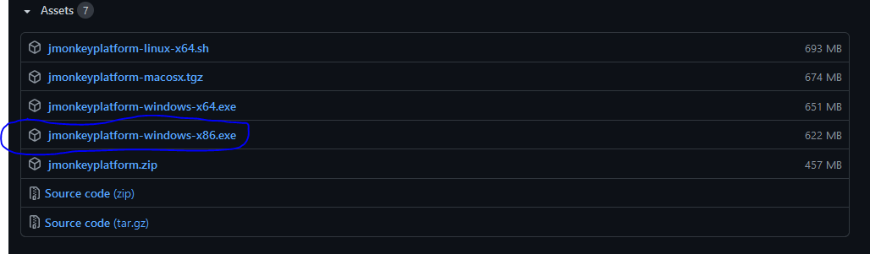

After launching the .exe file I was presented with the following installation wizard:

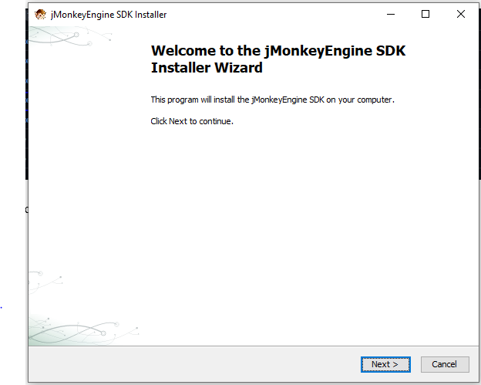

I kept the default installation path:

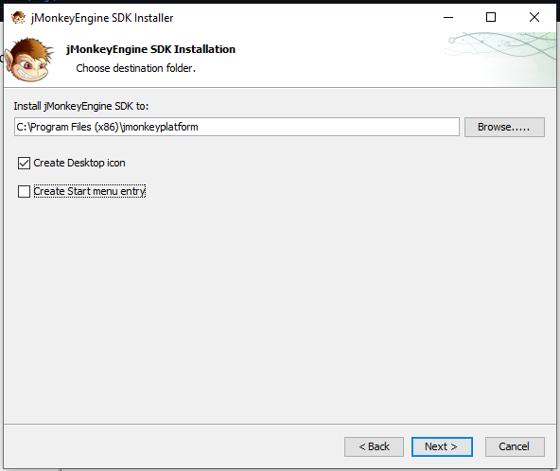

jMonkey installing:

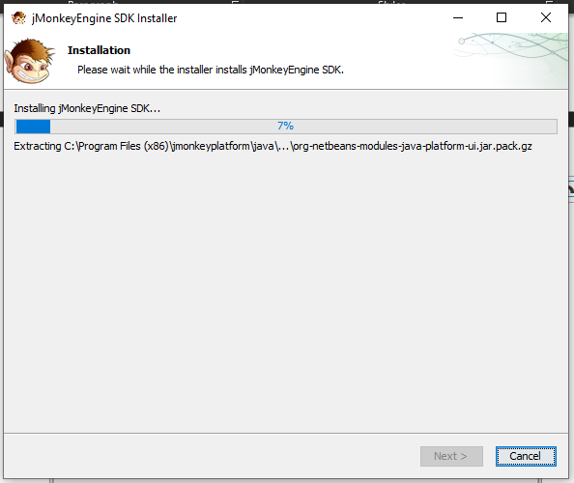

Once installation was complete, I got the following screen:

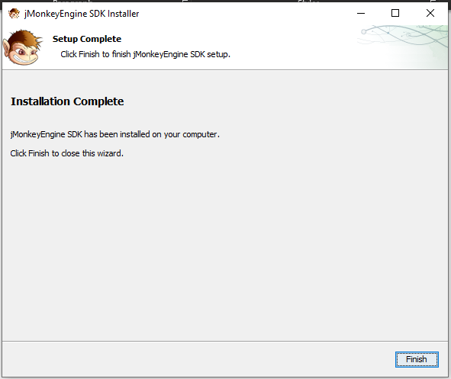

**jMonkey Hello World program**

I followed the guide here <https://wiki.jmonkeyengine.org/docs/3.4/tutorials/beginner/beginner.html> to create my first hello world program in jMonkey. After launching jMonkey, I created a new project by clicking File>New Project:

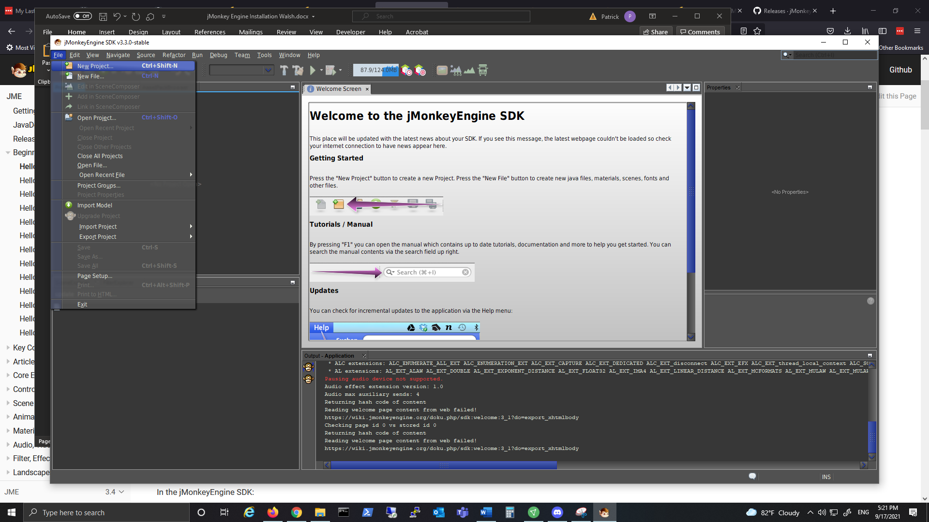

On the New Project menu, I selected JME3, BasicGame, then clicked Next:

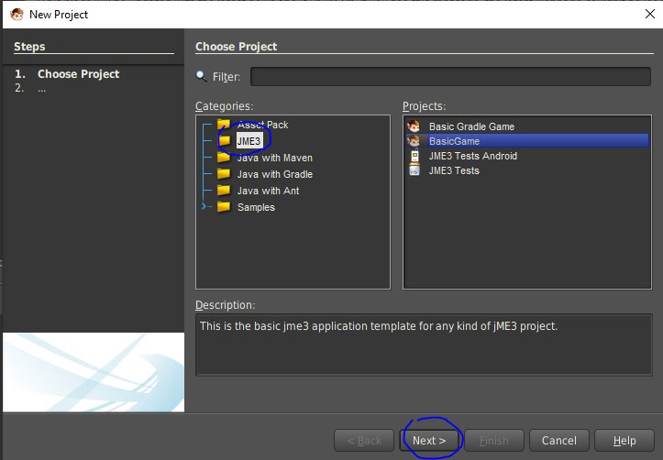

I gave the project a name and clicked Finish:

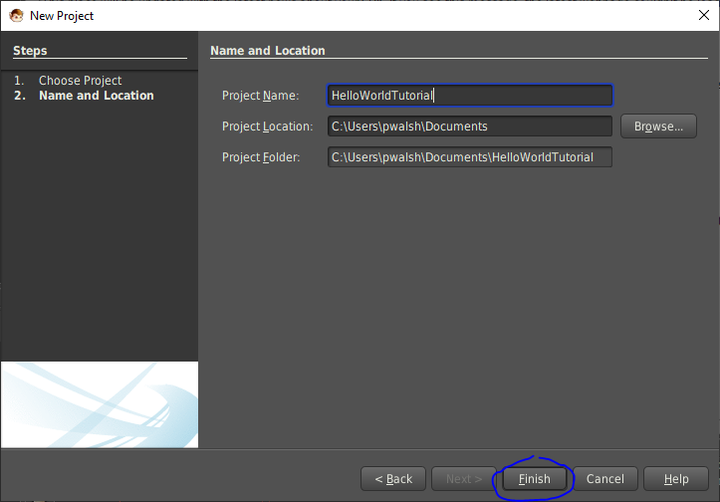

After clicking the Run button, I got the following window:

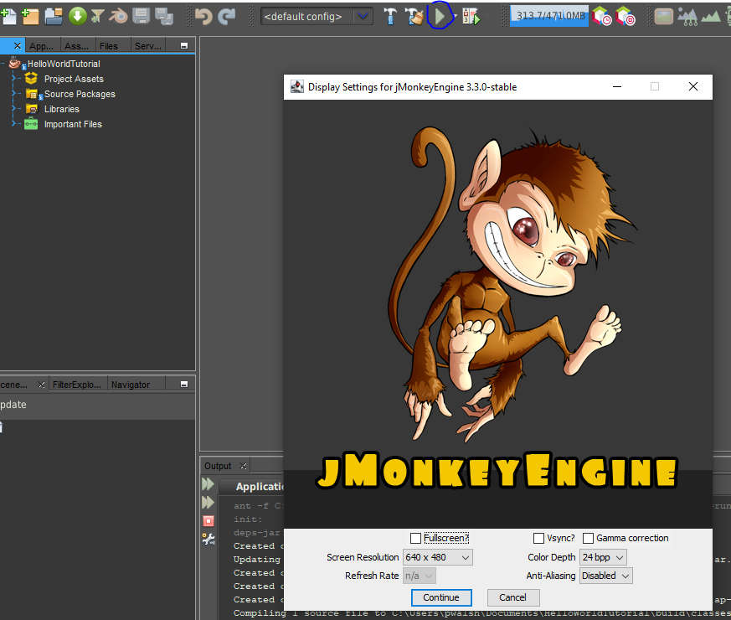

I clicked the Continue button at the bottom of the window and the game window was launched. The game consisted of a blue square that moved when I moved my mouse:

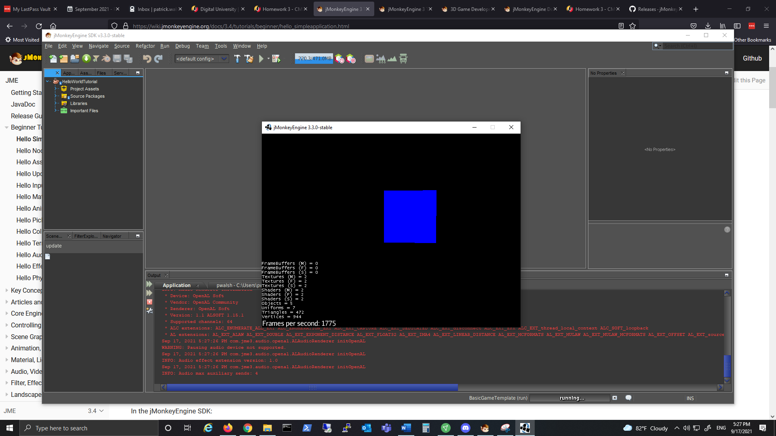

After hitting the Escape key, the game window closed:

